TRANSMITTAL HISTORY FOR
ARTS ENTREPRENEURSHIP NEW MINOR

Committee on Curriculum and Instruction
Draft Minutes

April 30, 2010 9:00 AM-11:00 AM

- Update on Arts Entrepreneurship Minor courses/pre-reqs
- Bus MHR 490:
- this course is a 4-credit course (not 5-credits as indicated in the Powerpoint Presentation of April 9);
- according to Rhonda Fisher (Director of the Entrepreneurship Minor and Associate Director of Student Services, FCOB Undergraduate Program): “The 290 prereq was approved over a year ago, but for the 09-10 academic year, we didn't enforce it since all students had not had the opportunity to take it the prior year. For this year we accepted Econ 200, AED Econ 200 or MHR 290. Effective 8/31/2010 only 290 will be the required pre-requisite.”
- The information contained in the CCI-approved proposal and advising sheet is consistent with this information.

ASC Committee on Curriculum and Instruction
4/9/10 Approved Minutes
1. Arts Entrepreneurship New Minor (Guest: Jane Cataldi)
- Overview by J. Cataldi (Dept of Art Education).
- Visual Arts is primary program of Dept of Art Education (focuses on K-12). APA (Arts Policy and Administration) program takes a wider range and focuses on public as a whole. APA has a multi-arts approach (not just visual). Arts live in an economic reality—hence necessity for Arts Entrepreneurship program. Starting about 2006, faculty looked at the Fisher Center for Entrepreneurial Studies, which uses a multidisciplinary approach. The Undergraduate Interdisciplinary Minor in Entrepreneurship has 2 required courses in Business (290 and 490) and a series of other courses. From that model, Art Education developed their model.

[Note: Mistake in slide above: Bus MHR 490 is 4 credit hours. (CAO)]
- Goals of Minor: To understand the principles of entrepreneurship as applied to arts and culture: For students to
- practice creative & critical thinking;
- recognize trends and opportunity for arts & culture in various environments;
- create social and economic value through innovative art practice;
- actively engage the public in arts and cultural activity.
- Student learning outcomes are for students to:
- understand the possibilities, problems and interventions impacting the contemporary arts and culture environment.
- map the relationships within of the creative sector: the artist, the artistic product/service, the industries, and the infrastructure;
- appreciate both similarities and differences among different arts fields (e.g., theatre, dance, museums, orchestras, etc.);
- interpret the role of social/cultural values, beliefs and attitudes related to audience participation, advocacy, and education in contemporary arts and culture.
- understand the legal, economic, & technological influences shaping the cultural landscape;
- understand the purpose, function, and professional planning and decision making of arts and cultural organizations.
- describe the internal structure, cultures and operations of non-profit arts/cultural organizations;
- examine issues of organizational governance, leadership, and human resources;
- design, implement, and evaluate innovative audience-focused programming;
- develop entrepreneurial skills vital in generating/managing revenues and resources;
- understand the professional role and leadership responsibilities of the artist and the cultural worker in society.
- reflect on the personal, social and cultural value of arts and culture;
- examine the non-profit, public, commercial, and academic career paths open to artists and those working in cultural fields;
- develop entrepreneurial skills for the marketplace of ideas, arts products, and cultural services;
- gain practical experience in arts and cultural venues through individual and group research projects, mentorships, internships and study abroad.

- Proposed course descriptions

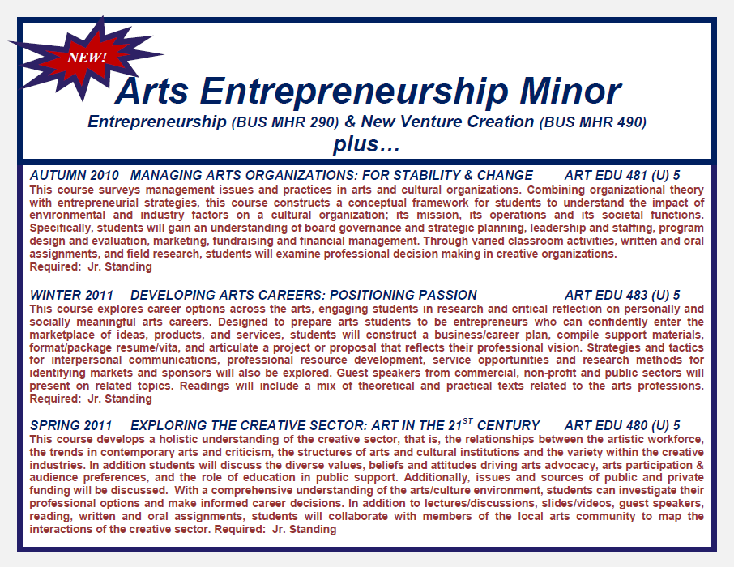

There was a discussion earlier about Bus MHR 490: question whether they wanted to maintain the prereq (Econ 200). It was resolved they would maintain the prereq.
[Note: CAO: Bus MHR 490’s only prereq is Bus MHR 290. According to Rhonda Fisher (Director of the Entrepreneurship Minor and Associate Director of Student Services, FCOB Undergraduate Program): “The 290 prereq was approved over a year ago, but for the 09-10 academic year, we didn't enforce it since all students had not had the opportunity to take it the prior year. For this year we accepted Econ 200, AED Econ 200 or MHR 290. Effective 8/31/2010 only 290 will be the required pre-requisite.”]

- Beyond the minor: possible directions:
  - Policy Focus: Prereq: AE 480
- Public Policy and the Arts
- Creative Sector & Creative Cities
- Managing Cultural Policy Change
- Issues across the Arts (Barnett Symposium)
- Key Policy Issues & Concepts in the Arts
  - Management Focus: Prereq: AE 481
- Arts/Cultural Institutions: Organizational Theory & Management Practice
- Nonprofit Arts Institutions, Governance, and Board Leadership
- Arts Participation, Cultural Programming, and Audience Development
- Arts/Cultural Organizations: Resource Management & Revenue Streams
- Arts/Cultural Mentorships in Management
- Discussion-Q&A
- The courses in the minor are taught out of Fisher & the Dept. of Art Education. Are the 5 courses offered more than once a year? In other words, what would happen in a student missed a course’s offering? A: At this point because of enrollment, the Dept of Art Education offers courses once a year. We are hoping that enrollment might increase and we might offer courses more frequently. The 2 Business courses are doing quite well and are offered several times a year. These are intro courses—much larger student population.
- Since all three art education classes require Junior standing, it could be a very tight fit. A: If many of the 5 courses are taken early, that person can use senior year to fill in the gap.
- It is important that the information about Econ 200 being a prereq to Bus MHR 490 be clear to students because this is a tight schedule. Point this out clearly in advising minor sheet.
- Jane Cataldi would like to clarify the prereq information now because she has several students who are interested in the program right now.
- Is order of these three art education courses important? A: As a personal preference, J. Cataldi believes that it might be better to take Art Ed 480 first, then rest. However, there is no established sequence.
- These will be 3-credit semester courses.
- For the three Art Education courses: plan on adding “permission of instructor.” In the past, sophomores have taken the course & it works well.
- Who is mostly interested in this minor? A: Most students come from College of Arts. Sometimes, Humanities, Fisher, or Public Policy.
- If Arts or Humanities students want to take the minor, is there an access problem? A: No. The Business courses are open courses--i.e. they are accessible to Arts and Humanities students; they are not courses that are designed solely for Business students.
- V. Williams confirms minor has been supported at every stage of its development.
Letter from A&H Subcom stands as motion to approve, 2nd Huffman, unanimously approved

CCI Arts and Humanities Subcommittee
Approved Minutes

- Arts Entrepreneurship New Minor
- The minor was first approved with contingencies by the historical College of the Arts Curriculum Committee in December 2008. Professor Wayne Lawson was hired and worked with Professor Michael Camp in the Business School to create the Arts Entrepreneurship Minor.
- Typo under VIII: Changing the Minor: “Any changes to the requirements must be approved by the Director of the Music, Media, and Enterprise Program and the MME Steering Committee.” This sentence should become: “Any changes to the requirements must be approved by the Director of the Arts Entrepreneurship Minor Program and the AEMP Steering Committee.”
- Section V: “This credit hour minor consists of . . .” should be: “This 24 credit hour minor consists of . . .”
- Typo under IX: “The Arts Entrepreneurship Minor requires a minimum of 25 credit hours of course work.” This should read: “The Arts Entrepreneurship Minor requires a minimum of 24 credit hours of course work.”
- This seems like a strong proposal.
Hubin, Miller, unanimously approved

